CNN-Based Alzheimer's Disease Diagnosis Using MRI Brain Images
Abstract
Alzheimer’s disease (AD) is a major public health priority. Hippocampus is one of the most affected areas of the brain and is easily accessible as a biomarker using MRI images in machine learning for diagnosing AD. In machine learning, using entire MRI image slices showed lower accuracy for AD classification. We present the select slices method by landmarks on the hippocampus region in MRI images. This study aims to see which views of MRI images have higher accuracy for AD classification. Then, to get the value of three views and categories, we used multiclass classification with the publicly available Alzheimer’s Disease Neuroimaging Initiative (ADNI) dataset using Resnet50 and LeNet. The models were used in a total dataset of 4,500 MRI slices in three views and categories. Our study demonstrated that the selecting slices performed better than using entire slices in MRI images for AD classification. Our method improves the accuracy of machine learning, and the coronal view showed higher accuracy. This method played a significant role in improving the accuracy of machine learning performance. The results for the coronal view were similar to the medical experts usually used to diagnose AD. We also found that LeNet models became the potential model for AD classification.
Existing system
In existing system, many machine and deep learning algorithms were using to predict this disease but all those algorithms were taking entire MRI scan input for prediction which is degrading prediction accuracy as entire image may contains irrelevant features which will be diagnose incorrectly.
Disadvantages:
- Low Accuracy: Using entire MRI slices may introduce irrelevant features and reduce classification accuracy.
- Increased Processing Time: Processing entire MRI images can require additional computational time.
- Irrelevant Feature Extraction: Unnecessary image regions may interfere with the identification of disease-related features.
- Limited Region-Specific Analysis: The system does not specifically focus on important brain regions associated with Alzheimer's disease.
- Reduced Classification Efficiency: Processing unnecessary image information may affect the overall efficiency of disease classification.
Proposed system
In proposed system, employing novel technique to extract affected regions such as Axial, Coronal and Sagittal from MRI scan images and this extracted brain images region will get trained with different deep learning algorithms such as Pre-trained Resnet50, Resnet50 and LENET and in all algorithms LENET is giving better accuracy.
Advantages:
- Improved Accuracy: Selecting relevant MRI slices can improve Alzheimer's disease classification performance.
- Reduced Processing Time: Processing selected MRI regions can reduce unnecessary computational work.
- Focused Feature Extraction: Emphasizes relevant brain regions associated with Alzheimer's disease.
- Multiple MRI Views: Uses Axial, Coronal, and Sagittal views for MRI-based classification.
- Model Comparison: Evaluates ResNet50, pre-trained ResNet50, and LeNet to identify an effective classification model.

Module Description:
1. MRI Image Input
This module collects MRI brain images from the publicly available Alzheimer's Disease Neuroimaging Initiative (ADNI) dataset. The images represent different stages of Alzheimer's disease, including Normal, Mild, Moderate, and Severe categories. These images serve as input for preprocessing and subsequent classification.
2. Image Preprocessing
This module prepares MRI brain images for deep learning analysis. It performs noise removal, image resizing, normalization, and skull stripping to improve image quality and extract relevant brain regions. These preprocessing operations help maintain consistency across images before feature extraction and classification.
3. Hippocampus Region and Slice Extraction
This module identifies relevant brain regions associated with Alzheimer's disease, particularly the hippocampus. It extracts selected MRI slices from three different views: Axial, Coronal, and Sagittal. Selecting relevant slices helps reduce unnecessary image information and focuses the classification process on potentially important brain structures.
4. Dataset Preparation
This module organizes the extracted MRI slices into a structured dataset for model development. It categorizes images according to their respective disease classes and divides the dataset into training and testing sets. Data augmentation can also be applied, if required, to increase training-image diversity and improve model generalization.
5. Deep Learning Model Training
This module trains and evaluates three deep learning approaches: pre-trained ResNet50, ResNet50 trained from scratch, and LeNet. ResNet50 extracts complex image features, while the pre-trained model uses previously learned features through transfer learning. LeNet performs feature extraction and classification using a CNN architecture. The models are trained on the prepared MRI images to identify patterns associated with different Alzheimer's disease categories.
6. Model Evaluation
This module evaluates the performance of the trained models using standard classification metrics, including accuracy, precision, recall, F1-score, and a confusion matrix. These metrics help compare the models, understand their classification performance, and identify potential errors in predicting Alzheimer's disease categories.
7. Alzheimer's Disease Classification
This module uses the trained model to classify MRI brain images into the supported categories: Normal, Mild Alzheimer's Disease, Moderate Alzheimer's Disease, and Severe Alzheimer's Disease. The predicted category is presented as the classification output. The system is intended to assist research and analysis; its predictions should not be treated as a standalone clinical diagnosis.

System Architecture:
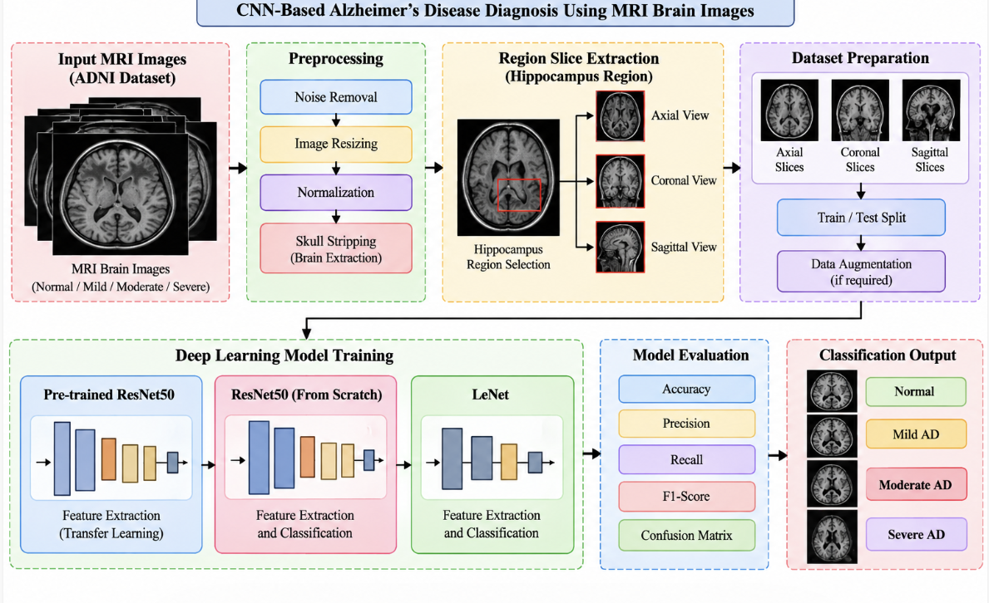
HARDWARE & SOFTWARE REQUIREMENTS:
HARDWARE REQUIRMENTS:
- processor : intel i3(min)
- Hard Disk : 40 GB.
- Floppy Drive : 1.44 Mb.
SOFTWARE REQUIRMENTS:
- Operating system : Windows 10 (min)
- Coding Language : python 3.7.9 with Jupiter notebook

